**Software Requirements Specification**

**for**

Project Management System

**Version 2.0 approved**

**Prepared by Sanket Meshram and Rohit**

**March 19, 2019**

**Table of Contents**

**Table of Contents ii**

**Revision History ii**

**1. Introduction 1**

1.1 Purpose 1

1.2 Document Conventions 1

1.3 Intended Audience and Reading Suggestions 1

1.4 Product Scope 1

1.5 References 1

**2. Overall Description 2**

2.1 Product Perspective 2

2.2 Product Functions 2

2.3 User Classes and Characteristics 2

2.4 Operating Environment 2

2.5 Design and Implementation Constraints 2

2.6 User Documentation 2

2.7 Assumptions and Dependencies 3

**3. External Interface Requirements 3**

3.1 User Interfaces 3

3.2 Hardware Interfaces 3

3.3 Software Interfaces 3

3.4 Communications Interfaces 3

**4. System Features 4**

4.1 System Feature 1 4

4.2 System Feature 2 4

4.3 System Feature 3 4

4.4 System Feature 4 4

4.5 System Feature 5 4

4.6 System Feature 6 4

4.7 System Feature 7 4

4.8 System Feature 8 4

4.9 System Feature 9 4

**5. Other Nonfunctional Requirements 4**

5.1 Performance Requirements 4

5.2 Safety Requirements 5

5.3 Security Requirements 5

5.4 Software Quality Attributes 5

**6. Other Requirements 5**

**Appendix A: Glossary 5**

**Appendix B: To Be Determined List 6**

**Revision History**

|  |  |  |  |
| --- | --- | --- | --- |
| **Name** | **Date** | **Reason For Changes** | **Version** |
| Project Management System | 19/03/2019 | Some extra classes are removed.  Project Manager is changed to professor. | 2.0 |
|  |  |  |  |

# **Introduction**

## **Purpose**

*To develop a fully functional and user interactive online software which can enhance and help various project management users to manage and compile their work efficiently and productively.*

## **Document Conventions**

*PML - Project management system*

*HTTP -Hyper text transfer protocol*

*UDP -User datagram protocol*

*TCP-Transfer control protocol*

## **Intended Audience and Reading Suggestions**

*This document is for faculties of university who want to closely monitor their project and for the team member associated to a given project.*

## **Product Scope**

*This document is for faculties of university who want to closely monitor their project.PML tries to reduce burden upon faculties . It will be also used by team member of project to give update to faculty.*

# **Overall Description**

## **Product Perspective**

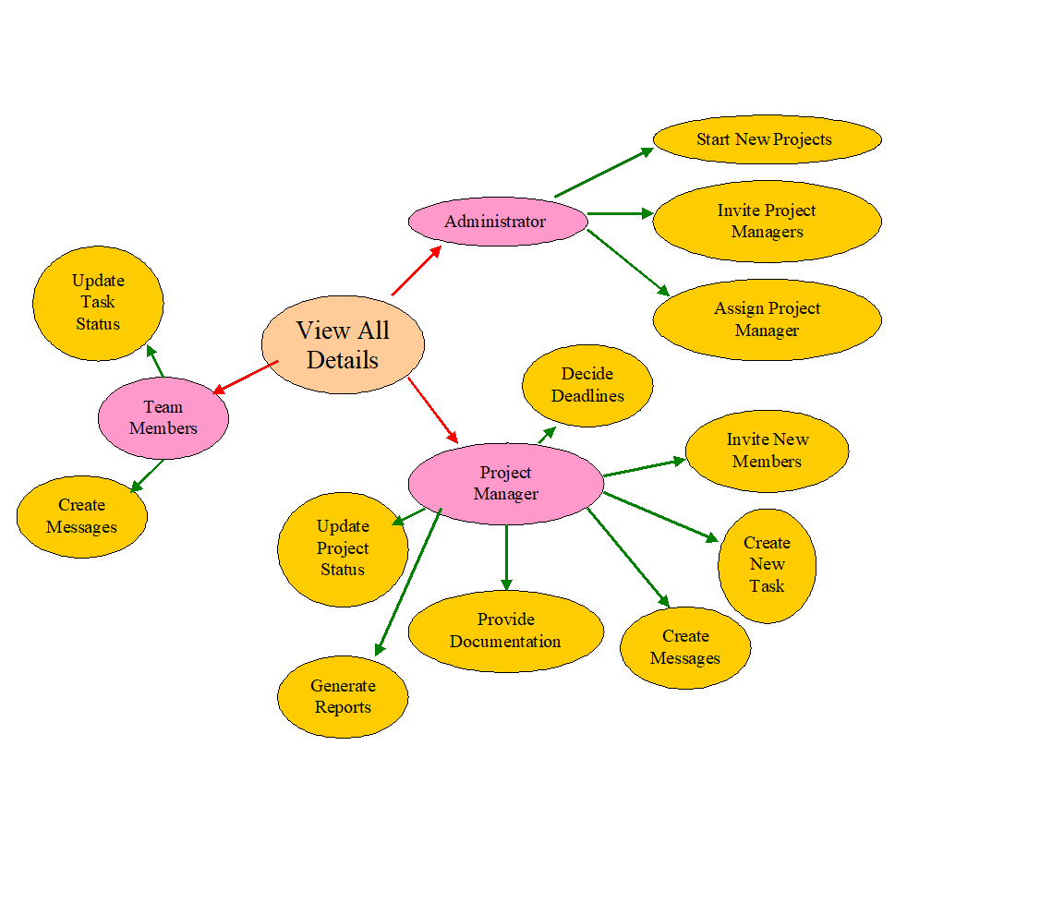

## **Product Functions**

* *Expense management : Allow Professor to monitor and manage expense*
* *Leave Application : Allow team member to apply for leave*
* *Scheduling Meeting : Allow Professor to schedule for meeting*
* *Salary Allocation : Professor can allot salary*
* *Create new project : Allow creation of new project by faculty*

## **User Classes and Characteristics**

* *Class* ***Professor*** *: is responsible for inviting and managing team members , assigning suitable task to members and providing report to Administrator.*
* *Class* ***Team_Members*** *: are responsible for updating task status and completing task before deadline.*

## **Operating Environment**

* *Microsoft Windows Operating system*
* *Linux Operating system*

## **Design and Implementation Constraints**

* *Programing Language : JAVA/Python*
* *Database :MySql*
* *Communication protocol : HTTP/TCP/UDP*

## **User Documentation**

*README.txt and documentation will be available as guide for users.README.txt will contain installation instruction and documentation will contain tutorial for usage of this application.*

## **Assumptions and Dependencies**

*This software require either local area network or proper network connectivity for communication between the user of product.*

# **External Interface Requirements**

## **User Interfaces**

*The PMS will have following user interfaces:*

1. *Login: to allow the entry of only authorized users through valid login id and password*
2. *Project Detail: to maintain project detail*
3. *\*Project Staff detail: to maintain detail about the user involved in the given project*
4. *\*Expense Management : to maintain detail about the expense of the given project*
5. *\*Meeting scheduler: to schedule meeting*
6. *\*Generate Report: to make a report*
7. *Leave application:Allow member to apply for leave*
8. *\*Leave approval:allow Professor to approve for leave*
9. *Create New Project*
10. *\*Invite team member*
11. *\*Task Allocation*

*(*)this symbol denote this feature is only accessible by Professor*

## **Hardware Interfaces**

* *Processor (CPU) with 2 gigahertz (GHz) frequency or above*
* *A minimum of 1 GB of RAM*
* *Monitor Resolution 1024 X 768 or higher*
* *A minimum of 1 GB of available space on the hard disk*
* *Internet Connection Broadband (high-speed) Internet connection with a speed of 4 Mbps or higher / Local area network*
* *Keyboard and a Microsoft Mouse or some other compatible pointing device*

## **Software Interfaces**

* Windows / Linux operating system
* Platform: Java/Python 3 Language

## **Communications Interfaces**

*This software uses UDP/TCP and HTTP/HTTPS architecture.*

# **System Features**

## Expense Management

4.1.1 Description and Priority

This feature is high priority. This feature will maintain the expense distribution of system.

4.1.2 Stimulus/Response Sequences

*After login the Professor can have option to go to Expense management*

4.1.3 Functional Requirements

REQ-1: Professor can allot fund to respective team member

REQ-2: Project manager can keep track of fund spent

## Leave Application

4.2.1 Description and Priority

This feature is medium priority.This feature will help user to apply for leave and know its status

4.2.2 Stimulus/Response Sequences

*After login the project management can have option to go to Expense management*

4.2.3 Functional Requirements

REQ-1: System manager can allot fund to respective software

REQ-2: System manager can keep track of fund spent

## Projects

4.3.1 Description and Priority

This feature is higher priority.This feature will help user to check details of project he is involved in.

BUT ,Professor will have an extra feature known as PROJECT STAFF DETAIL with in every project . Which will help him to recall who is involved in project.

4.3.2 Stimulus/Response Sequences

*After login the project User will have option to go to Projects.*

4.3.3 Functional Requirements

REQ-1: Everyone involved in project can track progress of project.

## Meeting Scheduler

4.4.1 Description and Priority

This feature is higher priority.This feature will help Professor to Schedule meeting . Meeting notification will pop up on everyone’s Notification Area who is involved in project.

4.3.2 Stimulus/Response Sequences

*After login the project User will have option to go to Meeting Scheduler .*

4.3.3 Functional Requirements

REQ-1: Everyone involved in project will be able to know meeting time and venue .

## 

## Generate Report

4.4.1 Description and Priority

This feature has lower priority.This feature will help Professor to Generate report .

4.3.2 Stimulus/Response Sequences

*After login the project User will have option to go to Generate report.*

4.3.3 Functional Requirements

REQ-1: Professor can easily generate report to give to sponsor .

REQ-2: Team member can apply for leave.

## Leave Application

4.4.1 Description and Priority

This feature has medium priority.This feature will help Professor to Approve leave and team member to apply for leave .

4.3.2 Stimulus/Response Sequences

*After login the team member will have tab to apply for leave and Professor will have tab to approve for leave.*

4.3.3 Functional Requirements

REQ-1: Professor can approve leave .

## Create new project

4.4.1 Description and Priority

This feature has high priority.This feature will help Professor to create new project and various other option of management of project will be there.

4.3.2 Stimulus/Response Sequences

*After login the admin will have option to go to Create Project. After that Professor can fill necessary detail.*

4.3.3 Functional Requirements

REQ-1: Professor can easily create project sponsor and fill necessary requirement .

## Invite Team member

4.4.1 Description and Priority

This feature has medium priority.This feature will help Professor to invite team member.

4.3.2 Stimulus/Response Sequences

*After login the Professor can select project and then invite team member.*

4.3.3 Functional Requirements

REQ-1: Professor can invite team member for corresponding project .

## Task Allocation

4.4.1 Description and Priority

This feature has medium priority.This feature will help Professor to allocate task to certain team member/s .

4.3.2 Stimulus/Response Sequences

*After login the Professor will have option to go to certain project and allocate the task.*

4.3.3 Functional Requirements

REQ-1: Professor can allocate task to team members .

# **Other Nonfunctional Requirements**

## **Performance Requirements**

5.1.1 Response time

*The maximum response time for the certain task will be 1 minute.*

5.1..2 Capacity

*The maximum number of people will depend on system.*

## **Safety Requirements**

*This software would be protected by login based access.*

## **Security Requirements**

*The given system will be protected by login based system to avoid access of unwanted people into the system.The data transfer will be protected by network server.*

## **Software Quality Attributes**

This software will be portable and available 24/7. This software would be released after through testing to make is error free and further maintenance would be provided to improve reliability and reusability.

# **Other Requirements**

*This system will store data on remote server which may require periodic deduction of money.*

**Appendix A: Glossary**

*PML - Project management system*

*HTTP -Hyper text transfer protocol*

*UDP -User datagram protocol*

*TCP-Transfer control protocol*

**Appendix B: To Be Determined List**

1. *The type of server will be decided during testing phase.*
2. *Type of database will be decided later.*
3. *GUI mechanism can be changed to provide perfect product to user.*